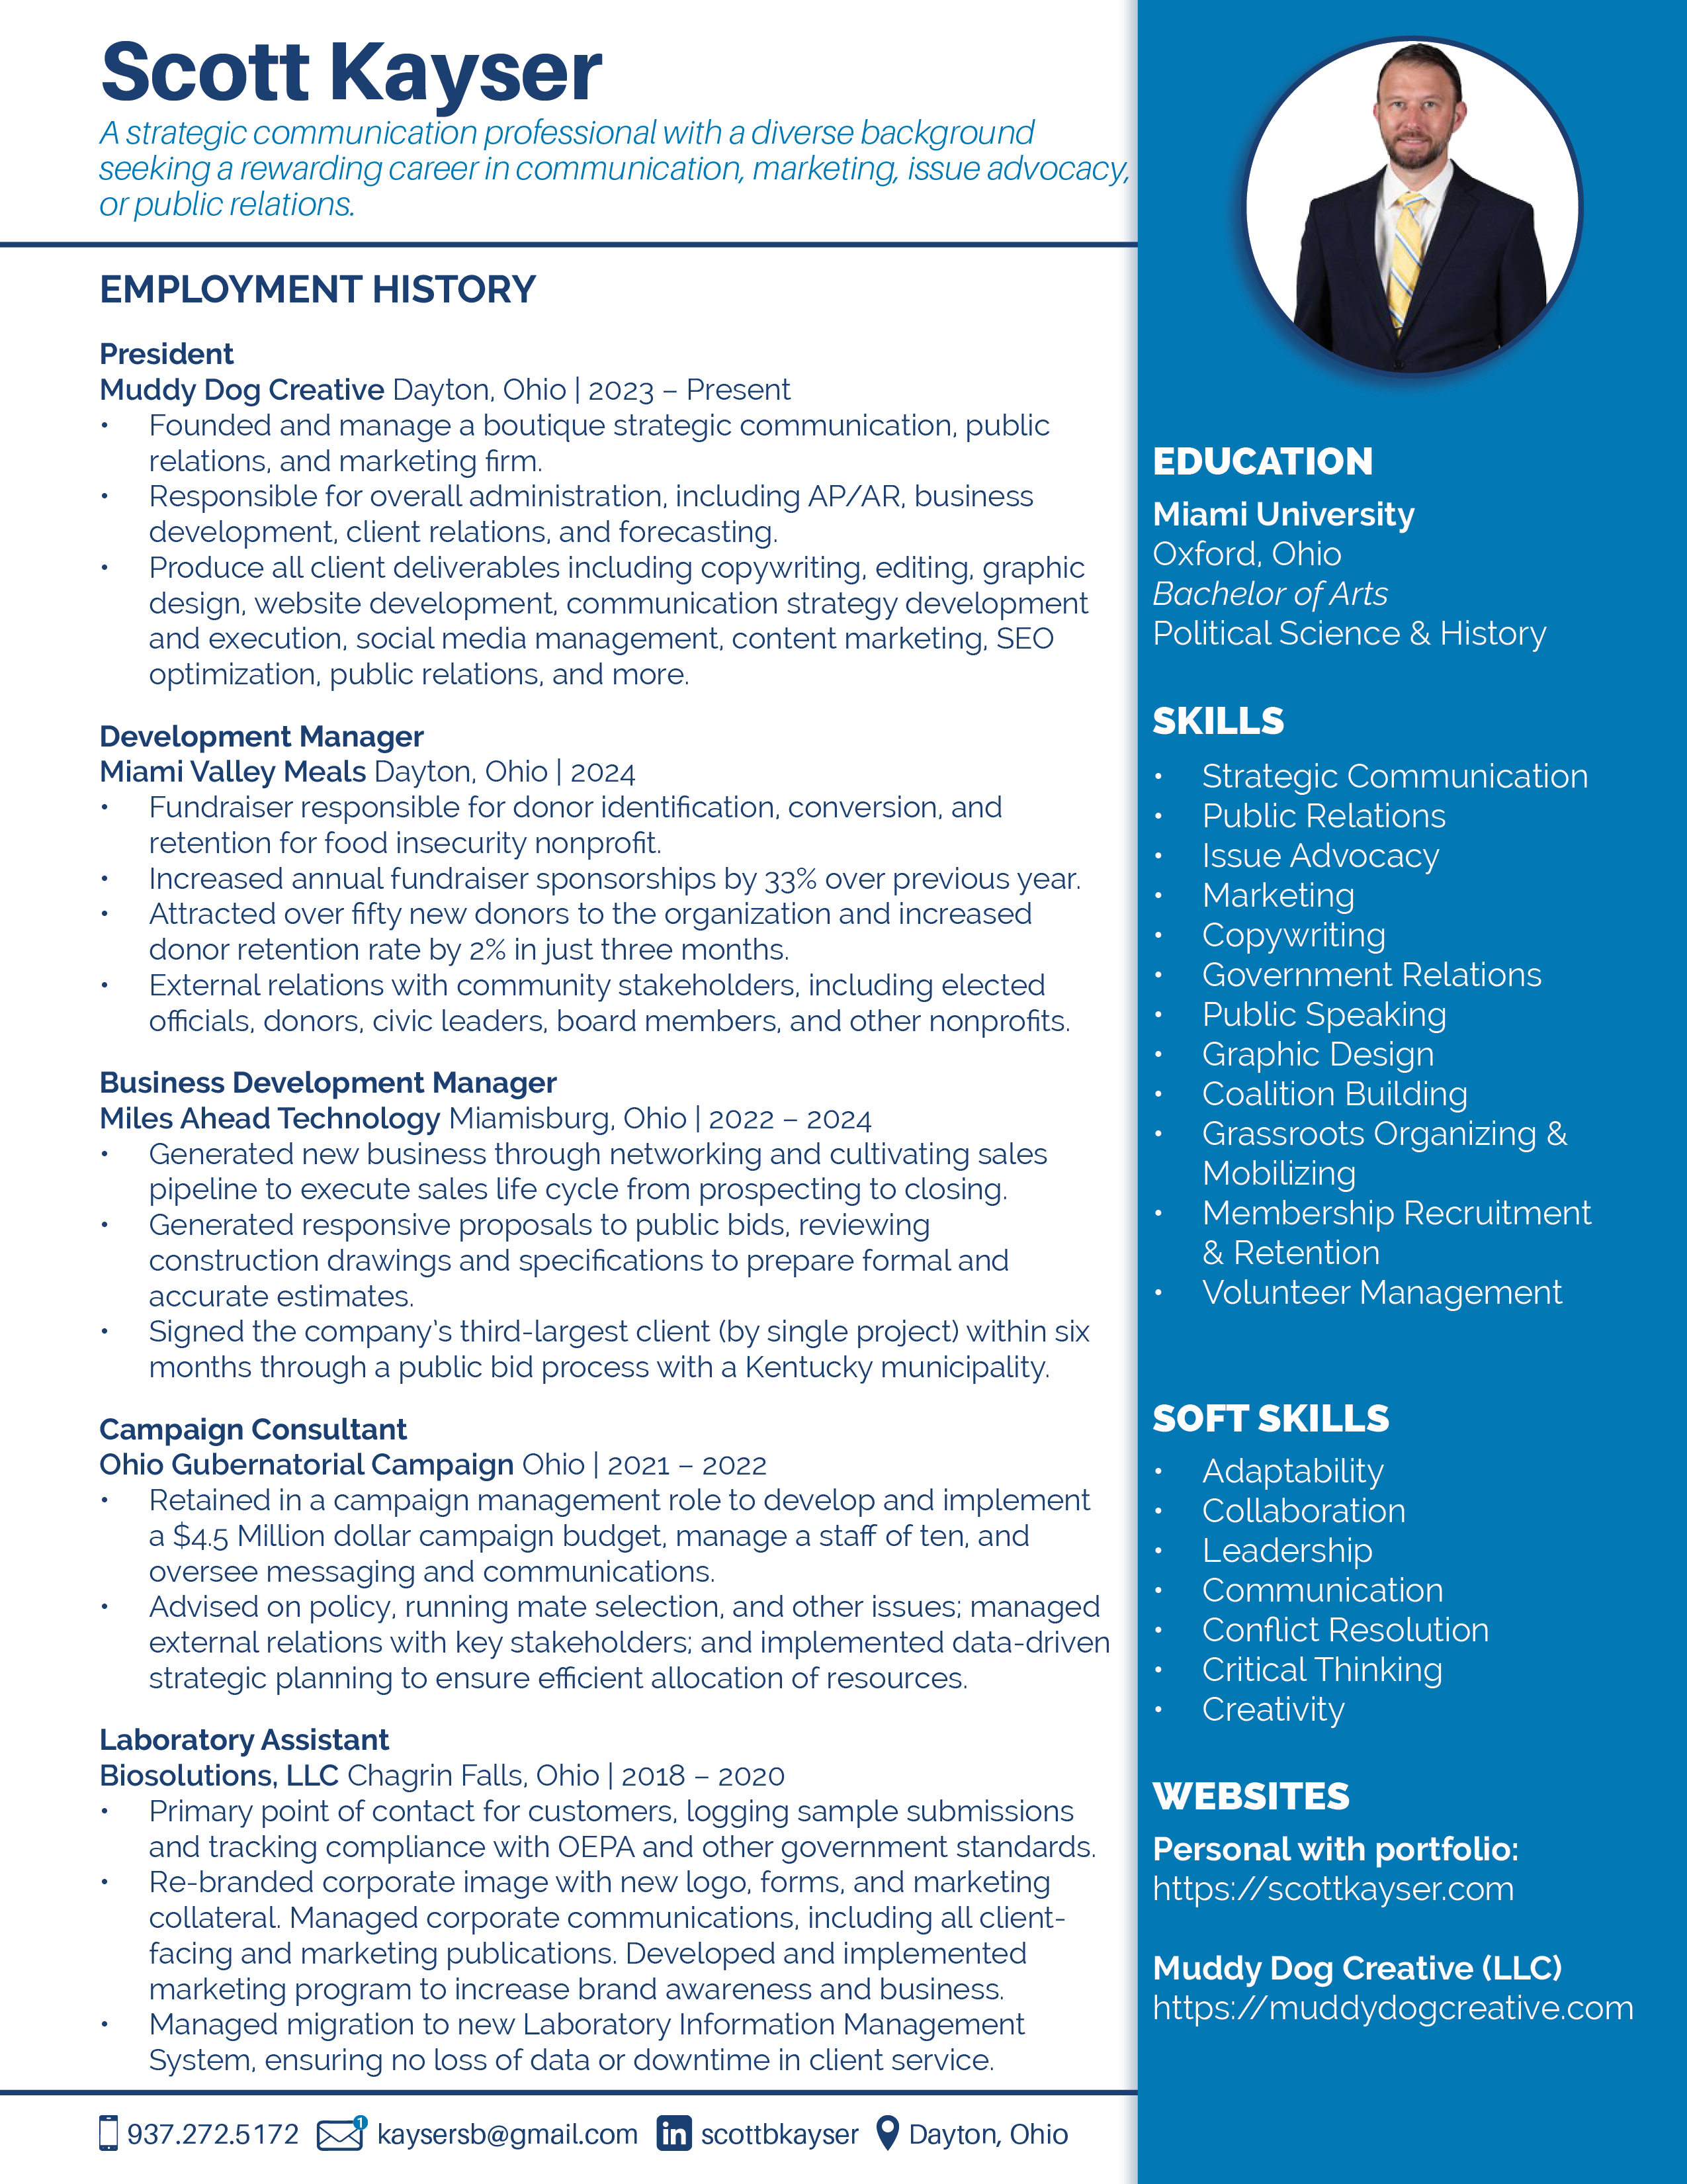
Scott Kayser | Strategic Communication Professional
TEL: 937.272.5172 | Email: kaysersb@gmail.com | Location: Dayton, Ohio, United States
Website: https://scottkayser.com and https://muddydogcreative.com

EDUCATION

Miami University Oxford, Ohio (2001 – 2005)
Bachelor of Arts, Political Science & History

SKILLS

Strategic Communication, Public Relations, Issue Advocacy, Marketing, Copywriting, Editing, Government Relations, Public Speaking, Graphic Design, Coalition Building, Grassroots Organizing & Mobilizing, Membership Recruitment & Retention, Volunteer Management, Adobe Creative Suite (Illustrator, Photoshop, Indesign, etc.), Microsoft Office Suite (Outlook, Word, Excel, Access, PowerPoint, etc.), WordPress, HTML, CSS, CRM (HubSpot, ConnectWise)

EMPLOYMENT HISTORY

President
Muddy Dog Creative Dayton, Ohio | 2023 – Present
- Founded and manage a boutique strategic communication, public relations, and marketing firm.
- Responsible for overall administration, including AP/AR, business development, client relations, and forecasting.
- Produce all client deliverables including copywriting, editing, graphic design, website development, communication strategy development and execution, social media management, content marketing, SEO optimization, public relations, and more.

Development Manager
Miami Valley Meals Dayton, Ohio | 2024
- Fundraiser responsible for donor identification, conversion, and retention for food insecurity nonprofit.
- Increased annual fundraiser sponsorships by 33% over previous year.
- Attracted over fifty new donors to the organization and increased donor retention rate by 2% in just three months.
- External relations with community stakeholders, including elected officials, donors, civic leaders, board members, and other nonprofits.

Business Development Manager
Miles Ahead Technology Miamisburg, Ohio | 2022 – 2024
- Generated new business through networking and cultivating sales pipeline to execute sales life cycle from prospecting to closing.
- Generated responsive proposals to public bids, reviewing construction drawings and specifications to prepare formal and accurate estimates.
- Signed the company’s third-largest client (by single project) within six months through a public bid process with a Kentucky municipality.

Campaign Consultant
Ohio Gubernatorial Campaign Ohio | 2021 – 2022
- Retained in a campaign management role to develop and implement a $4.5 Million dollar campaign budget, manage a staff of ten, and oversee messaging and communications.
- Advised on policy, running mate selection, and other issues; managed external relations with key stakeholders; and implemented data-driven strategic planning to ensure efficient allocation of resources.

Laboratory Assistant
Biosolutions, LLC Chagrin Falls, Ohio | 2018 – 2020
- Primary point of contact for customers, logging sample submissions and tracking compliance with OEPA and other government standards.
- Re-branded corporate image with new logo, forms, and marketing collateral. Managed corporate communications, including all client- facing and marketing publications. Developed and implemented marketing program to increase brand awareness and business.
- Managed migration to new Laboratory Information Management System, ensuring no loss of data or downtime in client service.
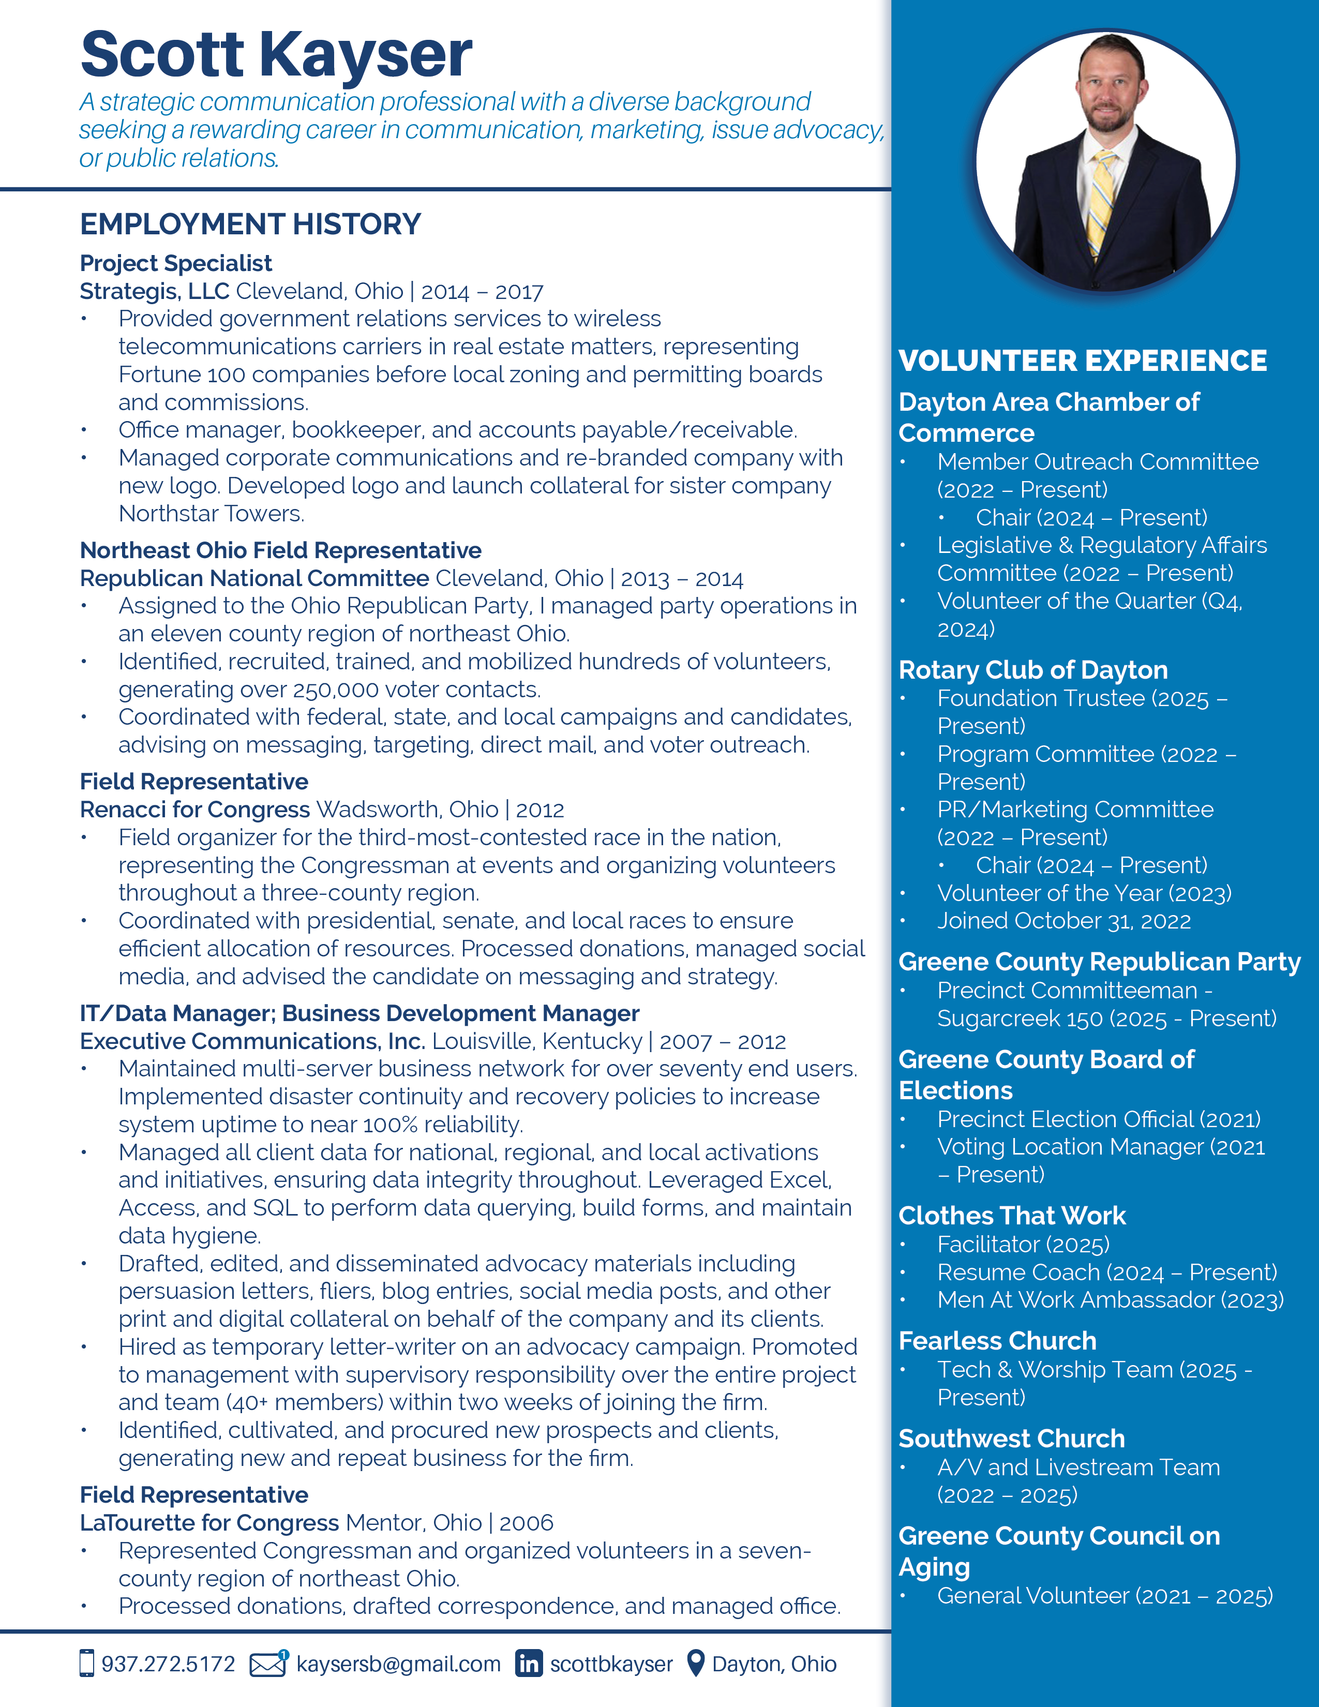

Project Specialist
Strategis, LLC Cleveland, Ohio | 2014 – 2017
- Provided government relations services to wireless telecommunications carriers in real estate matters, representing Fortune 100 companies before local zoning and permitting boards and commissions.
- Office manager, bookkeeper, and accounts payable/receivable.
- Managed corporate communications and re-branded company with new logo. Developed logo and launch collateral for sister company Northstar Towers.

Northeast Ohio Field Representative
Republican National Committee Cleveland, Ohio | 2013 – 2014
- Assigned to the Ohio Republican Party, I managed party operations in an eleven county region of northeast Ohio.
- Identified, recruited, trained, and mobilized hundreds of volunteers, generating over 250,000 voter contacts.
- Coordinated with federal, state, and local campaigns and candidates, advising on messaging, targeting, direct mail, and voter outreach.

Field Representative
Renacci for Congress Wadsworth, Ohio | 2012
- Field organizer for the third-most-contested race in the nation, representing the Congressman at events and organizing volunteers throughout a three-county region.
- Coordinated with presidential, senate, and local races to ensure efficient allocation of resources. Processed donations, managed social media, and advised the candidate on messaging and strategy.

IT/Data Manager; Business Development Manager
Executive Communications, Inc. Louisville, Kentucky | 2007 – 2012
- Maintained multi-server business network for over seventy end users. Implemented disaster continuity and recovery policies to increase system uptime to near 100% reliability.
- Managed all client data for national, regional, and local activations and initiatives, ensuring data integrity throughout. Leveraged Excel, Access, and SQL to perform data querying, build forms, generate reports, and maintain data hygiene.
- Drafted, edited, and disseminated advocacy materials including persuasion letters, fliers, blog entries, social media posts, and other print and digital collateral on behalf of the company and its clients.
- Hired as temporary letter-writer on an advocacy campaign. Promoted to management with supervisory responsibility over the entire project and team (40+ members) within two weeks of joining the firm.
- Identified, cultivated, and procured new prospects and clients, generating new and repeat business for the firm.

Field Representative
LaTourette for Congress Mentor, Ohio | 2006
- Represented Congressman and organized volunteers in a seven- county region of northeast Ohio.
- Processed donations, drafted correspondence, and managed office.

VOLUNTEER EXPERIENCE
Dayton Area Chamber of Commerce
- Member Outreach Committee (2022 – Present); Chair (2024 – Present)
- Legislative & Regulatory Affairs Committee (2022 – Present)
- Volunteer of the Quarter (Q4, 2024)

Rotary Club of Dayton
- Foundation Trustee (2025 – Present)
- Program Committee (2022 – Present)
- PR/Marketing Committee (2022 – Present); Chair (2024 – Present)
- Volunteer of the Year (2023)

Greene County Board of Elections
- Precinct Election Official (2021); Voting Location Manager (2021 – Present)

